THE LIFE-GIVING GLACIER
INTERMEDIATE LEVEL

The Life-giving Glacier is one out of nine podcasts produced by Katrine Nyland for The Icefjord Centre in Ilulissat.

Subjects
Cross-curricular – mathematics and nature/culture

Learning goals
- The students acquire fundamental knowledge about glaciers.
- The students acquire knowledge about the Sermeq Kujalleq glacier´s special influence on
the Icefjord and Ilulissat being inscribed on the UNESCO World Heritage List, and the impact it has on life in and around the Icefjord.
- The students practice their skills in communication and cooperation.

Organization
We recommend that the students work in pairs or singly. Depending on what suits each student best and the competences to be developed. Keep in mind that your best friend not necessarily is the one you collaborate best with. Working together is about working together and not just being together.

Guide to the Book Creator book
The Book Creator book The Life-giving Glacier is a student’s book associated with the podcast The Life-giving Glacier.
The duration of the podcast is 3:57.
The activities have been designed to focus on the students’ investigative, experimental and creative approach to learning.

The process consists of three steps:
- Preparation before listening to the podcast.
- Listening to and working with the podcast.
- Further work with topics and insights from the podcast.

We recommend that you listen to the podcast before presenting it to the students.

Page by page guide
– the Book Creator student’s book “The Life-giving Glacier”

Welcome to the Icefjord Centre, pages 4-7
The students meet the Icefjord Centre in two pictures, showing summer and winter respectively.
In class you can talk about:
- The Icefjord Centre – a very special building in a very special place.
- What the surroundings around the Centre look like.
- The difference between summer and winter.
- How summer and winter differ where you live.

Map Ilulissat, pages 8-9
Talk about the map:
- How many people live in Ilulissat and how many people live in the town or the settlement where you live?
- Which other towns do you know of in Greenland and where are they situated?

I live here, pages 10-11
The students see part of a world map.
The task now is to move the red marker down into the map in order to show where each student lives.
The marker is found in the white box and can be drawn into the map.

In class you can talk about:
- Differences and similarities between Ilulissat and your own town or settlement.

The Icefjord/Kangia, pages 12-13
The students see a map of Ilulissat Icefjord/Kangia: It is the area marked with a red line that is inscribed on the UNESCO World Heritage List.
The students are to estimate approximately how large an area this section covers. They insert their result in the blue box on the map.
Note: at the bottom of the map there is a scale.
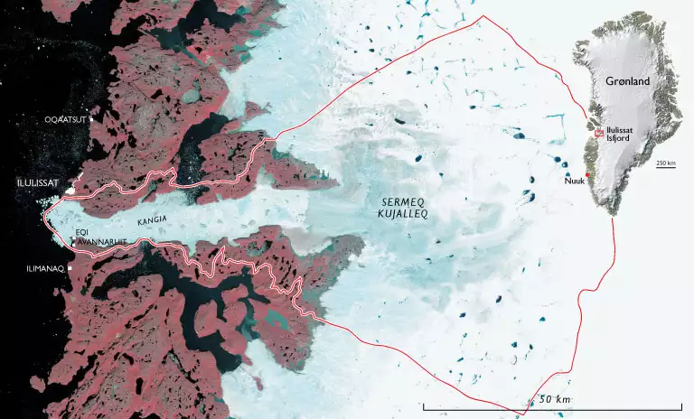
Source: GEUS.dk

In class you can talk about:
- What is UNESCO? (United Nations Educational, Scientific and Cultural Organization is UN´s organization for education, culture, communication and science)
  - That the Icefjord and the Sermeq Kujalleq glacier are a unique site and therefore on the UNESCO World Heritage List.
You might let the students on their own hand find knowledge about:
- Other sites that are inscribed on the World Heritage List and what the criteria are to get inscribed on the list?

Listen and talk, pages 14-15
Now it is time for the students to listen to the podcast The Life-giving Glacier.
They find the podcast by clicking on the picture on page 14.
Before listening to the podcast, you can give a short introduction to the contents of the podcast.

Contents of the podcast

- It starts with the sound of the glacier calving.
- Katrine Nyland tells about
- The Icefjord (in Greenlandic called Kangia) that has been inscribed on the UNESCO World Heritage List.
- The enormous icebergs that float towards the mouth of the fjord and constantly change colors.
- The glacier that grows smaller in the winter. It almost stops moving, but then gets active again in the summer and pushes the great icebergs out into the Icefjord.
- Malik who is a helicopter pilot and for periods at a time flies over the glacier on a daily basis.
- Malik tells about
- How the tourists have difficulties quite grasping how gigantic the Icefjord and the glacier are. At first they think it is a long white line, until they land three kilometers from the edge of the glacier, then they understand how enormous it is.
- The glacier front that rises from 100 to 300 meters. When the glacier is preparing to calve, it becomes high because the ice is pushed upwards. Then, when the ice breaks off further in, it becomes lower again. A repeated cycle.
- That he is still surprised by the dazzling sight that meets him, even though he has been out at the glacier more than 1000 times.

It is recommended that the students listen in pairs or small groups.

Let the students spend a few minutes discussing what they have heard in the podcast.

On page 15 the students are to make small sound recordings where they tell about the podcast. The pictures on the page can help them remember what they have heard.

Sound recording: see instruction 1 here.

The recording will now be represented by a small sound icon. This icon can be placed wherever you wish on the page. You can listen to the recording over and over again.

Review in class
We recommend that you have a joint discussion in class when the work with pages 14-15 is finished.
We recommend that you support the discussion by writing concepts and keywords on the board.

In class you could talk about:
- What surprised the students when listening to the podcast.
- What kind of life might the glacier bring with it?
- Concepts and keywords that the students encountered in the podcast.

In the text below you can find inspiration for the class discussion.
In the Book Creator book there are some pages with tasks connected to some of the concepts.
You can add more pages yourself for other topics, concepts and keywords you discuss.

Concepts and keywords

- Glacier – the word glacier means ”a river of ice”. A glacier is a large mass of slowly moving ice. When the weight of new snow becomes sufficiently heavy on the inland ice, the lowest section of ice is pressed out towards the coast. The stream of ice that is caused by this, is called a glacier.
What do the tourists think the glacier looks like when they see it from the helicopter?
Why does Malik land three kilometers from the edge of the glacier?
- Calving – when blocks of ice break off the edge of the glacier and fall into the sea because of gravitation, it is called calving. You could say that the glacier is “giving birth” to icebergs and ice floes. The great calvings, where large parts of the edge of the glacier is loosened, only happen a few times during the summer, but smaller bits of ice break off the edge all the time and can be seen the whole year round.
- In the podcast the term the edge of the glacier is used and this is the term that we use in these materials. Another and mostly used term is glacier front.

Why does the glacier front vary from being 100 to 300 meters high?

- Km³ – the students are probably familiar with area/m² – on paper they draw a square, the space on the inside of the lines is called area. Now they can also draw a box; the space inside the lines is the volume/m³.

How many km³ does the Sermeq Kujalleq glacier calve a year?

- A cycle – is characterized by something, that more or less regularly returns, repeating itself. The ice has a cycle. The movements of the ice are influenced by the seasons´ cold and heat.
When is the glacier active?
When does the glacier almost stop moving?
- MALIK– is a helicopter pilot and flies with tourists out over the Icefjord and the Sermeq Kujalleq glacier. Even though he has been out by the glacier over 1000 times, he still gets surprised and dazzled every time he is there. He is still fascinated by the enormous forces that are out there.

What could it be that fascinates Malik out by the glacier?
What is a glacier, pages 16-17
On page 16 the students will read the text about glaciers.
They can find more knowledge about glaciers here.
On page 17 the students must insert three different pictures of glaciers.
To each picture they make a small description in the form of an audio file.

Sound recording: see instruction 1 here

Calving, pages 18-19
On pages 18-19 the students read the text about calving.
After reading, they can watch a short film about a large piece of ice breaking off near Ilulissat.
Talk about the film in class. Write keywords on the board and let the students write them down. They can then use them in the task My reference book on pages 22-23.

The life-giving glacier, pages 20-21
On the pages there is an illustration of a so called food web with the different fish and animals that live in the Icefjord.
The students must try to determine their species.
They can either choose to name the individual animals or they can choose to make an audio file where they tell about the animals, they can see in the picture.

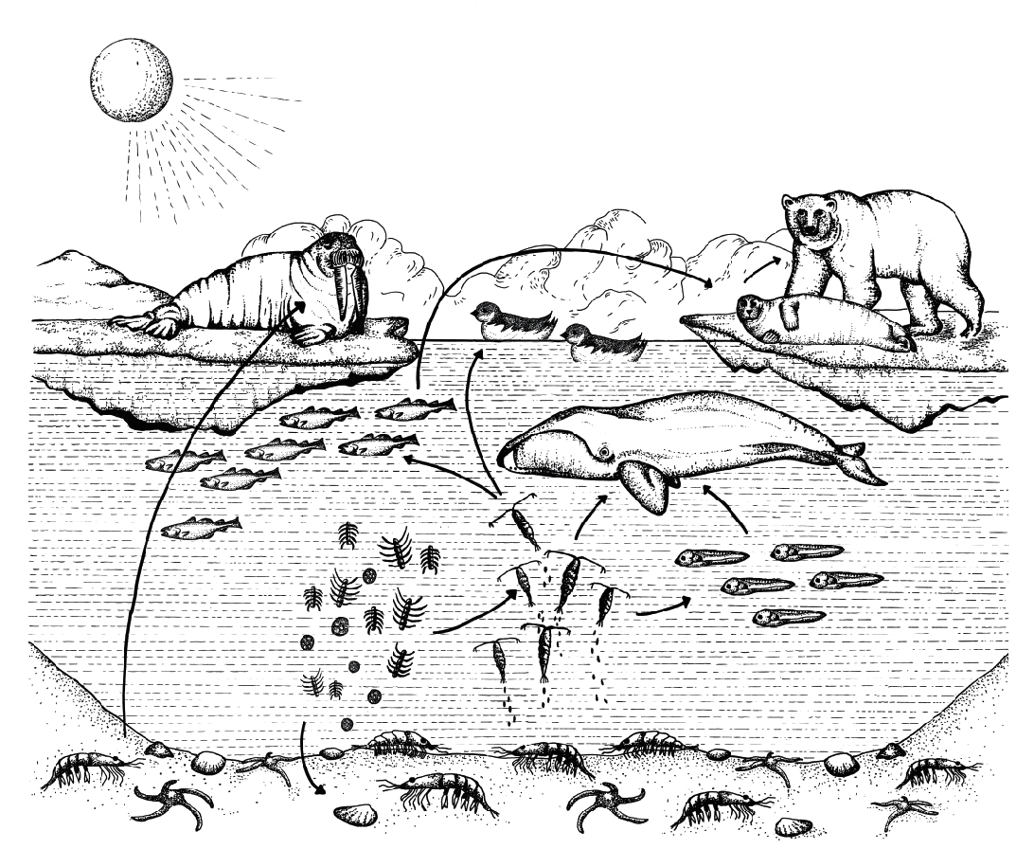

Model: The Icefjord Centre

By following the arrows you can discuss in class which animals each of the other animals eat.

Find more knowledge here.

Sound recording and insertion of text: see instruction 1 and 3 here.

My reference book, pages 22-23
On pages 22 and 23 the students can make short sentences or small stories using the keywords and concepts that you have gone through. They can write them, record them as an audio file or make a drawing and insert the picture. Their products will be part of the further work with the podcast.

Sound recording and insertion of text: see instruction 1 and 3 here

On the track of Malik´s flying route, pages 24-27
In the task the students are asked to make a promotion for Visit Greenland´s helicopter tours.
On page 24 they are invited to read about the case with the following invitation:

Dear students,
The Icefjord Centre has been asked to promote Visit Greenland´s helicopter trips to the Sermeq Kujalleq glacier.
For this we need your help.
We wish to make a flyer or a pamphlet that:
- describes the trip with the helicopter out to the glacier in words and pictures.
- informs about the price.
- makes it possible to book a trip.

We look forward to receiving a presentation from you.
Best regards,
The Icefjord Centre

The students are free to choose whether they want to do the task directly in the Book Creator book or whether they do the task using another digital tool or they can use an analogue solution.
If the task is solved totally or partially using another tool than Book Creator, pictures of the product must be inserted in the Book Creator book.

Sound recording and insertion of text: see instruction 1 and 3 here.

Find more knowledge here

Evaluation
The students present their products to the class.
Make sure that the framework for feedback is positive criticism. The students should be supported in assessing what is good – and what might be done better. Find more inspiration here.
Not specifically with a view to making new products, but foremost to let the students discover and work with this kind of constructive and positive criticism.
If you intend to work with some of the other podcasts from the Icefjord Centre, it might make sense to save the students’ Book Creator book so that the work, they have done with it, can be used again.
If you wish to let the students make use of the feedback they have received from the class, you could reserve time for them to continue their work with their products. So that they can use the feedback they have received from each other to change things in their product.

Colophon
The podcast The Life-giving Glacier has been created by the Icefjord Centre in Ilulissat.
The teaching material for the podcast has been developed by Lotte Brinkmann and Daniella Maria Manuel, Anholt Læringsværksted with feedback from Leg med IT.
The student’s book in Book Creator has been developed as part of the project Nutaaliorta from Kivitsisa.
The template was designed by Rikke Falkenberg Kofoed and Daniella Maria Manuel, Leg med IT.

The teaching material The Life-giving Glacier is published under a Creative Commons crediting license CC:BY.
The texts, assignments and pictures can be shared, reproduced and adapted, with the proviso that “The Life-giving Glacier by The Icefjord Centre Ilulissat” is credited as the source.

