Life as a Hunter
Intermediate level
Life as a Hunter is one out of nine podcasts produced by Katrine Nyland for The Ilulissat Icefjord Centre.

Subjects
Cross-curricular – mathematics and nature/culture.

Learning goals
- The students acquire knowledge about daily life in a hunting and fishing family in the 1950s/1960s in Ilulissat.
- The students acquire special knowledge about the importance of the Icefjord to the children growing up at that time.
- The students practise their skills in communication and cooperation.
Organisation
We recommend that the students work in small groups, pairs or singly. Depending on what suits each student best and the competences to be developed. Keep in mind that your best friend is not necessarily the one you collaborate best with. Working together is about working together and not just being together.
Guide to the Book Creator book
The Book Creator book Life as a Hunter is a student’s book associated with the podcast Life as a Hunter.
The duration of the podcast is 4:40.
The activities have been designed to focus on the students’ investigative, experimental and creative approach to learning.

The process consists of three steps:
- Preparation before listening to the podcast.
- Listening to and working with the podcast.
- Further work with topics and insights from the podcast.
We recommend that you listen to the podcast before presenting it to the students.

Page by page guide – the Book Creator book
“Life as a Hunter”
Welcome to the Icefjord Centre, pages 4-7
The students meet the Icefjord Centre in two pictures, showing summer and winter respectively.
In class you can talk about:
- What the Icefjord Centre is.
- What the surroundings around the Centre look like.
- The difference between summer and winter.
- How summer and winter differ where you live.
Map Ilulissat, pages 8-9
Talk about the map:
- How many people live in Ilulissat, and how many people live in the town or the settlement where you live?

Towns and settlements in Greenland, pages 10-11
Which other towns and settlements in Greenland do you know?
Place a red marker and write the name of the town/settlement.

I live here, pages 12-13
The students see part of a world map.
The task now is to move the red marker down into the map in order to show where each student lives.
The marker is found in the white box and can be drawn into the map.
In class you can talk about:
- Differences and similarities between Ilulissat and your own town or settlement.
Fishing in the Icefjord, pages 14-15
On page 14 the students see a picture from 1925 that shows fishing going on at the ice edge, in technical language called the ice front.
In class you can talk about what you see in the picture. Let the students go into details. For example:
- How many people are there?
- What are the men doing and what are the women doing?
- How is the catch brought home?
- A mother is carrying a child on her arm. Where is she in the picture?
- Two dogs at a dinghy. Where are they in the picture?
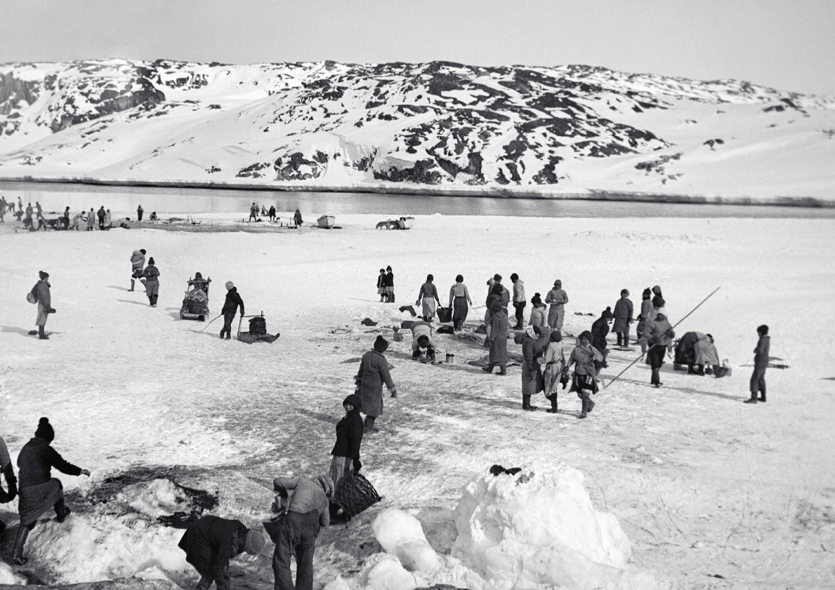

Fishing at the ice edge, Ilulissat, 1925.

On page 15 the students are to search for pictures showing how fishing is done nowadays with dinghy, ships or trawlers. They insert the pictures in the frame.

Search for and insert pictures see instruction 1 here.

In class you can discuss the significant differences between then and now.
Listen and talk, pages 16-17
Now it is time for the students to listen to the podcast Life as a Hunter. They find the podcast by clicking on the picture on page 16.

Before listening to the podcast, you can give a short introduction to the contents of the podcast.
Be aware that Mikkel tells his story in Greenlandic. The story is then retold in English.
The contents of the podcast
Mikkel tells:
- that he was born in 1940 and grew up in a hunting and fishing family in Ilulissat.
- that since he was 12 years old, he has worked as a fisherman and therefore he has a special connection to the Icefjord.
- that his father was both hunter and fisherman and that there was no doubt that Mikkel also would be a hunter or fisherman or both. These were his only options.
- that the dogs, who in those days moved around freely, were the most important. From the age of 10, he looked after the family's dogs in the summer.
- about being close to his father and about how his father taught him and his brothers that life as a fisherman on the Icefjord can be dangerous. His father also taught him how to fish by hand, remove the entrails and cut out the fish.
- about the ice that in all kinds of weather slowly moves out towards the sea. At full moon, when the current is stronger, the ice moves faster.
- about how the fishermen used to estimate how far the ice on the Icefjord moved per day. This is called the “movement” of the ice.
- about the importance of keeping an eye on the “movement”, so that they could remove their equipment (hunting and fishing gear) in time, before the current took it.
- about the Ilulissat fjord (the Icefjord) having a deep place in his heart.
It is recommended that the students listen in pairs or small groups.
Let the students spend a few minutes discussing what they have heard in the podcast.
On page 17 the students are to make small sound recordings where they tell about the podcast. The pictures on the page will help them remember what they have heard.
Sound recording, see instruction 1 here.
The recording will now be represented by a small sound icon. This icon can be placed wherever you wish on the page. You can listen to the recording over and over again.
Review in class
We recommend that you have a joint discussion in class when the work with pages 16-17 is finished.
While doing this, it would be a good idea to support the discussion by writing concepts and keywords on the board. Let the students take notes – these will be useful in the task “My reference book” on pages 20-21.
In class you could talk about:
- What it was like, growing up in a hunting and fishing family
  - An example: the children were working from the age of 10-12.
    - What kind of jobs do you have (the students)?
  - Dangers lurking on the Icefjord.
  - The special connection Mikkel has to the Icefjord.
    - Is there a certain place that you (the students) have a special connection to?
- Mikkel was to become a hunter and fisherman just like his father. There were no other options unless you went to a boarding school in Aasiaat. (Mikkel mentions this in the podcast in Greenlandic.)
In the text below you can find inspiration for the class discussion.
In the Book Creator book there are tasks associated with some of the concepts.
You can add more pages in the book for other topics, concepts and keywords that you discuss.

Concepts and keywords
- Hunter/fisherman – a hunter/fisherman is a person who makes a living hunting and fishing in Greenland. They both hunt and fish. Mostly they fish and they especially fish a certain species, the Greenland halibut. In the podcast Mikkel tells about growing up in a hunting and fishing family. Find inspiration here. Choose English by clicking on the Danish flag.

Mention some of the animals and fish that are hunted/caught in and around the Icefjord.

- The dogs – when getting out to the fishing grounds and bringing home the catch, the sledge dogs were the most important. Nowadays all the dogs are tethered, but in the past, they moved around freely and were fed with fresh fish at the harbour. From the age of 10, the children were taught how to take care of the dogs. Find more knowledge in Qimmeq on pages 36-37.

Since 1954 the dogs have to be tethered. Why?

- Calving – when blocks of ice break off the glacier front and fall into the sea because of gravitation, it is called calving. You could say that the glacier is “giving birth” to icebergs and ice floes. When Semeq Kujalleq calves and the ice is pressed out into the Icefjord, the fishermen must take special precautions.

Which precautions must the fishermen take, especially at full moon?

- Full moon – there is a full moon approximately once a month. The Moon’s phases are determined from the Moon’s position between the Earth and the Sun. When the Earth is between the Sun and the Moon, the Moon is fully illuminated by the Sun. Then you say that the moon is full. At full moon the tide is especially strong and therefore there is a stronger current that makes the icebergs drift faster out to the sea.

What do you know about the phases of the Moon?

” The Movement”, pages 18-19
On page 18 the students are to read the following text:
When the glacier calved and the inland ice was pushed out into the Icefjord, the fishermen called it the "movement".
The ”movement” was measured by placing a marker one day and returning the next day to estimate how many steps the ice had moved.
In one day, it used to move 28 steps. At full moon it moved 31.5 steps.

On page 19 the students are to estimate how far the ice moves in one day and in two weeks respectively.
Find a suitable place for the measurements, for example the schoolyard. Mark where the measurement begins with a line. Let each student walk 28 steps. Place a marker. Measure the distance between the two markers.
The result of the measurement is inserted in the top box on page 19.

Hereafter the students are to estimate how far the glacier moves in two weeks by multiplying their result with 14.

In class you can talk about the small differences there are between the student's measurements.

My reference book, pages 20-21
On pages 20 and 21 the students make sentences or small stories using the concepts and keywords that you have gone through. They can write them, record them as an audio file or make a drawing and insert the picture. Their products will be used in the further work with the podcast.

Sound recording and insertion of pictures, see instruction 1 and 3 here.

Life in a hunting/fishing family, pages 24-25
As a completion of the task, the students now make an audio story/podcast in the form of an interview about life in a hunting/fishing family. Two by two the students plan an interview and interview each other.
The audio file is recorded directly in the book.
As an illustration to accompany the audio story, the students create a picture.
They can find inspiration in the podcast graphics on page 16. To create the picture the students can make use of photos, drawings, linoleum print or collage. The illustration is inserted on page 25.

Sound recording and insertion of pictures, see instruction 1 and 3 here.

Evaluation
The students show their products to the class.
Make sure that the framework for feedback is positive criticism. The students should be supported in assessing what is good – and what might be done better. Find more inspiration here.
Not specifically with a view to making new visual stories, but foremost to let the students discover and work with this kind of constructive and positive criticism.
If you intend to work with some of the other podcasts from the Icefjord Centre, it might make sense to save the students’ Book Creator book, so the work they have done with it can be used again.
If you wish to let the students make use of the feedback, they have received from the class, you could reserve time for them to continue their work with their products. So that they can use the feedback they have received from each other to change things in their product.
Colophon
The podcast Life as a Hunter has been created by the Icefjord Centre in Ilulissat. The teaching material for the podcast has been developed by Lotte Brinkmann and Daniella Maria Manuel, Anholt Læringsværksted with feedback from Leg med IT.

The student’s book in Book Creator has been developed as part of the project Nutaaliorta from Kivitsisa. The template was designed by Rikke Falkenberg Kofoed and Daniella Maria Manuel, Leg med IT.

The Qimmeq project has been developed by Ilisimatusarfik and the University of Copenhagen. The children’s non-fiction book “Qimmeq – Kalaallit qimmiat qimuttoq – the Greenland sled dog” was produced by Anne Katrine Gjerløff, Ilisimatusarfik and the Natural History Museum of Denmark.
The teaching material Life as a Hunter is published under a Creative Commons crediting licence CC:BY.
The texts, assignments and pictures can be shared, reproduced and adapted, with the proviso that “Life as a Hunter by The Icefjord Centre Ilulissat” is credited as the source.

