FREEDOM AND DANGERS
INTERMEDIATE LEVEL

Freedom and Dangers is one out of nine podcasts produced by Katrine Nyland for The Icefjord Centre in Ilulissat.

Subjects
Cross-curricular – languages and science

Learning goals
- The students acquire a fundamental knowledge about climate changes with warmer weather that makes the ice melt.
- The students acquire knowledge about the importance of the ice for life around the Icefjord.
- The students practise their skills in communication and cooperation.

Organisation
We recommend that the students work in pairs or singly. Depending on what suits each student best and the competences to be developed. Keep in mind that your best friend is not necessarily the one you collaborate best with. Working together is about working together and not just being together.

Guide to the Book Creator book
The Book Creator book Freedom and Dangers is a student’s book associated with the podcast Freedom and Dangers.
The duration of the podcast is 3:38.
The activities have been designed to focus on the students’ investigative, experimental and creative approach to learning.

The process consists of three steps:
- Preparation before listening to the podcast
- Listening to and working with the podcast
- Further work with topics and insights from the podcast

We recommend that you listen to the podcast before presenting it to the students.

Page by page guide
– the Book Creator student’s book “Freedom and Dangers”

Welcome to the Icefjord Centre, pages 4-7
The students meet the Icefjord Centre in two pictures, showing summer and winter respectively.
In class you can talk about:
- What the Icefjord Centre is.
- What the surroundings around the centre look like.
- The difference between summer and winter.
- How summer and winter differ where you live.

Map Ilulissat, pages 8-9
The students see a map of Greenland. There is a marker that shows where Ilulissat is situated.
In class you can discuss:
- What you see on the map.
- How many people live in Ilulissat.
- What else do you know about Greenland and Ilulissat?
- Do you know the names of other places on the map?

I live here, pages 10-11
The students see part of a world map.
The task now is to move the red marker down into the map in order to show where each student lives.
The marker is found in the white box and can be drawn into the map.
In class you can talk about:
- Where is your town or settlement situated?
- How many people live in the town or settlement where you live.
- Do you know the name of other places on the map?

Listen and talk, pages 12-13
Now it is time for the students to listen to the podcast Freedom and Dangers.
They start the podcast by clicking on the icon in the middle of page 12.
It is recommended that the students listen in pairs or small groups.

Before listening to the podcast, you could give a short introduction to the contents of the podcast.

- Ane Sofie tells about
  - the special feeling of freedom in the middle of nature
  - the season for dog sledding becoming shorter and shorter
- Flemming tells about
  - perils on the ice – ”listen to your dogs”
  - the normal route out to the hunting cabin and the fishing grounds of
10-15 km
  - unpredictable ice/a new 40 km route over the mountains
- Klaus tells about
  - the episode where his dog team is so eager to get out on the ice that they run before he gets them fastened to the sledge. He tells how he gets picked up by Villy Siegstad (former Greenlandic champion in dog sledding – let the students find information about this).
  - the dogs that are full of pranks and mischief on short trips, but on the long trips, e.g. 1400-1500 km over the ice sheet, find a rhythm as if they are dependent on each other.
  - about how the dogs, after a long trip over the ice sheet (1½ months), “had other plans” and right away sought towards the dog lot at the Icefjord Centre.

Let the students spend a few minutes discussing what they have heard in the podcast
with the student sitting next to them.

On page 13 the students are to make small sound recordings where they tell about the podcast. The pictures on the page will help them remember what they have heard.

Insertion of sound see instruction 1 here

Review in class
We recommend that you have a joint discussion in class when the work with pages 14-15 is finished.
We recommend that you support the discussion by writing and maybe illustrating concepts and keywords on the board.

In class you could talk about:
- What surprised the students when listening to the podcast.
- Concepts and keywords that the students encountered in the podcast.

In the text below you can find inspiration for the class discussion.
In the Book Creator book there are some pages with tasks connected to some of the concepts. You can add more pages yourself for other topics, concepts and keywords you discuss.

Concepts and keywords

- Freedom – Ane Sofie is in the middle of the nature she loves.
For Ane Sofie freedom means that she can be herself and proud of her working dogs. The nature Ane Sofie is in, is the landscape around the Icefjord.
When do you feel free?
When do you become proud?
What does the nature surrounding you look like?

- Dangers – the ice is an unpredictable partner.
The ice and nature offer freedom, but they can also mean dangers. Rising temperatures make the ice melt faster than just 10-20 years ago, so that it becomes more unpredictable. This means that you have to be very aware of where you drive the dog sledge.
Do you meet dangers in your everyday life?
How do the dogs help discover dangers on the ice?

- The dog handler – the driver of the dog sledge.
Ane Sofie and Flemming are dog handlers and sledge drivers

Can you be a driver with something else than sled dogs?
What do you think is important when you are a sledge driver?

- Dog teams and traces – the sled dogs are joined in a team. They are fastened to the sled by harnesses and traces.
When you put together a dog team, you have to think about the relationship the dogs have to each other. There have to be both strong dogs and good lead dogs.
When you have found the dogs that you want in your dog team, the dogs have to be fastened to the dog sledge. This you do with harnesses and traces. The harness is on the sled dog, the traces connect the harnesses to the dog sledge. The lines are often arranged in the form of a fan.

Why is it important to assemble all the sled dogs in a dog team?
Why is it important to be aware of the relationship between the dogs when you assemble a dog team?

- Hunting cabin – a cabin used by hunters and fishermen.
Close to Ilulissat there are two hunting cabins. Both of them are municipal. The cabins are placed where there are good hunting grounds. These are situated between 15 and 40 km from the town, so the fishermen spend the night in the cabins when they go ice fishing. The cabins are very primitive. You sleep on a big shelf (sometimes many at the same time), so if it gets too warm, you lie down on the floor.

What kind of fish are caught in the Icefjord?

- Rescue operation – rescuers go out to help people in distress, either by helicopter, ambulance or boat.
When the ice becomes insecure, fishermen and dogs sometimes need to be rescued out on the ice.

Have you been in an ambulance, or do you know someone who has?
Do you think there is any difference between rescue operations in Denmark and Greenland?

The hunting cabin, pages 14-15
On pages 14-15 there is a map over the area around Ilulissat, where the two hunting cabins, that Ane Sofies husband, Flemming, mentions in the podcast, are marked. Flemming tells us that they have been forced to change their route to get out to the ice and fish. Earlier the shortest route out to the ice was to drive the dog sledge out to a hunting cabin placed at Aallaaniarfik. That route was about 10-15 km.
But now there is not much ice on that route any longer, and therefore it is not passable. Now they have to drive over the high mountains to a hunting cabin near Aattartoq and that route is about 40 km long.

In addition to the map with the two hunting cabins on it, there is another map that shows how the line of the ice has changed from 1880 to 2018.

The students can use pages 14-15 to talk about the altered route that Flemming and his sled dogs are forced to use and how the climate changes have affected this. They must record their discussion and insert it as a sound recording.

Insertion of sound see instruction 1 here

Here are the rest of the concepts and keywords:

- Global – the global climate is becoming warmer and warmer.
The word “global” comprises the whole planet Earth. This means that it is getting warmer and warmer everywhere on Earth.

What is the difference between “global” and “local”?

- Climate changes - the weather becomes warmer and the ice melts.
When we talk about climate changes, we often also mention global warming and the greenhouse effect. The greenhouse effect arises when greenhouse gases are emitted, which happens in larger and larger amounts. The greenhouse gases work in a way that lets the light of the Sun pass through the Earth's atmosphere, and on the other hand they absorb the heat radiation from the Earth and send part of this heat back to Earth. So, the Earth becomes warmer and warmer. One example of a greenhouse gas is CO₂. In Greenland, the consequences of the climate changes are that the ice melts faster and earlier than it used to.

How does it influence Ane Sofie and Flemming that the ice melts faster and earlier?
In which connection have you heard about climate changes?

- Season – the season for dog sledding is becoming shorter and shorter.
The snow melts quicker, with the result that the season for dog sledding is changing. Formerly you could drive from the middle of October till May/June. Now you can drive from November/December till the end of April.
When there is not that much ice on the fjord, it is very dangerous to venture out on the Icefjord with a dog sledge.

In what way do you meet the word “season” in your everyday life?
Why has the season for dog sledding become shorter?

- The inland ice – an ice sheet that covers an area with ice.
The ice sheet in Greenland is the next largest in the world, the ice sheet on Antarctica is the largest.

What would the rest of the Earth look like if all of the inland ice melted?
Are there some countries that would be flooded if all of the inland ice melted?

Climate changes, pages 16-19
On pages 16-19 the students work with climate changes.

On pages 16-17 there are three different pictures about climate changes.

On page 18 there is a short introductory text about the concept of climate changes.
Let the students read the text and talk about the pictures with the student sitting next to them. After that you have a joint discussion with the whole class about what they have read and talked about.

Now the students are to find knowledge from a video. On page 18 there is a link to this English video:
video from the European Space Agency. The students use the video or search the Internet, to answer the questions on page 19. They insert the answer as a sound recording that fits the appropriate speech balloon.

Here are some proposals for more questions:
- What is the difference between natural and man-made climate changes?
- Who do the climate changes affect?
- What does it mean that it becomes like a greenhouse on Earth?
  - Please use the word greenhouse effect.

You can acquire more knowledge about climate changes here
Insertion of sound see instruction 1 here

My reference book, pages 20-21
On pages 20 and 21 the students can write sentences or small stories using the keywords that you have talked about. They can write them, record them as an audio file or make a drawing and insert the picture. Their products will be part of the further work with the podcast.

Insertion of sound, pictures & text see instructions 1, 2 & 3 here

The Greenland sled dog, pages 22-23
Here you can read or listen to the book Qimmeq, either in Greenlandic or in English, about the Greenland sled dog. Pages 34-37 in the book deals with the dog team and communication. These pages give the students the knowledge that they need in order to solve the next tasks.

My dog team, pages 24-27
Now the students are to make their own dog team. They must imagine that they are about to drive the trip from Ilulissat to the hunting cabin at Aattartoq, which is about 40 km away.
They need to put a dog team together, that can bring them there and back again safe and sound.

On pages 24-25 there is a picture of a dog team with red traces. Talk about the picture in class or just let the students use the picture as inspiration.

They can search for dog “shapes” in Book Creator and they can choose dogs of different breeds, and they can give their dogs names.
On pages 26-27 there is a dog and a line inserted, that symbolises a trace. These figures can be removed and adjusted freely when the students assemble their own dog team.

They should consider the following:
- How many dogs should their dog team consist of?
- Which qualities should their dogs have? E.g. lead dog, strong dog, team dog etc.
- Should some of the dogs have a shorter or longer trace than the other dogs, so that they can run in front or at the back?

Insertion of shapes see instruction 7 here

My stop motion film, pages 28-29

Now the students have worked with the Freedom and Dangers podcast, a dog team, a hunting cabin and climate changes. To conclude this work they will make a model of a dog sledge with a dog team and a sledge driver (it could be Ane Sofie, Flemming or the student him/herself).

You can find a template here

Have a look at this model for inspiration.
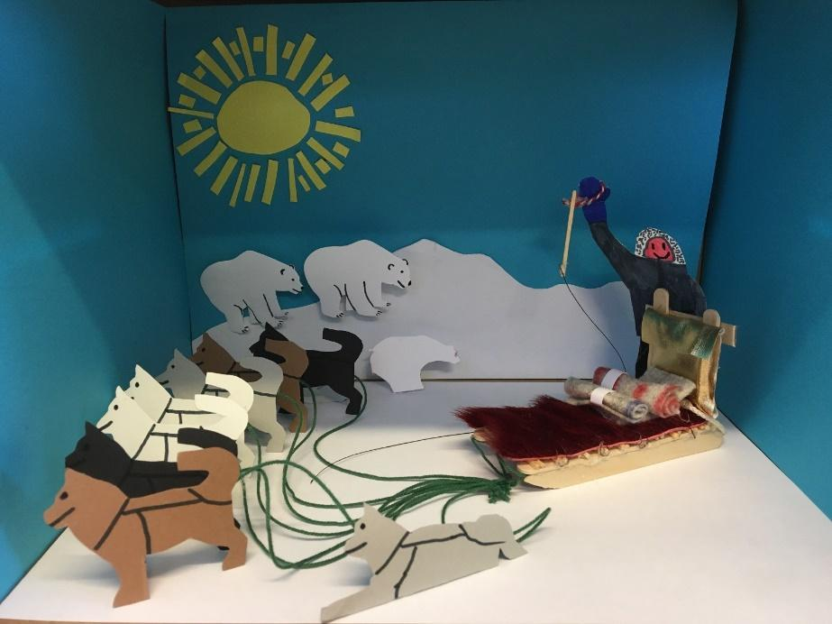
Model made by students from the settlement school in Qassiarsuk, using the template
in Papirklip / Kalaallit Numaat, Qiortakkat by Søren Thaae

When the students have made their model of a dog sledge with a dog team and a sledge driver they make a stop motion film.
For this they will need the app Stop Motion Studio. The app is free to download and use in its most basic form. This is fine for creating stop-motion films, with audio in high definition.

The students’ motion film should tell about:
- How you drive a dog sledge
- How you get out to the hunting grounds when the ice is not secure.

Organise the students in pairs, groups or individually. Depending on what suits the student best and which competences are to be developed.

When the students have made their stop motion film in Stop Motion Studio, it is saved in the camera roll and inserted on pages 28-29.

Insertion of video see instruction 5 here
Evaluation in class

The students see each other´s films and talk about the contents and about what they have learned through their work with the podcast Freedom and Dangers.
The focus is on the students´ communicative skills and competences in presenting.
Make sure that the framework for feedback is positive criticism. The students should be supported in assessing what is good – and what might be done better. Find more inspiration here.
Not specifically with a view to making new visual stories, but foremost to let the students discover and work with this kind of constructive and positive criticism.

If you intend to work with some of the other podcasts from the Icefjord Centre, it might make sense to save the students’ Book Creator book, so the work with it can be used again.

If you wish to let the students make use of the feedback from the class, you could reserve time for them to continue their work with their products. So that they can use the feedback from each other to make changes to their product.

Colophon
The podcast Freedom and Dangers has been created by the Icefjord Centre in Ilulissat.
The teaching material for the podcast Freedom and Dangers has been developed by Lotte Brinkmann from Anholt Læringsværksted with feedback from Leg med IT.
The student’s book in Book Creator has been developed as part of the project Nutaaliorta from Kivitsisa.
The template was designed by Rikke Falkenberg Kofoed and Daniella Maria Manuel, Leg med IT.

The Qimmeq project has been developed by Ilisimatusarfik and the University of Copenhagen. The children’s non-fiction book “Qimmeq – kalaallit qimmiat qimuttoq – the Greenland sled dog” was produced by Anne Katrine Gjerløff, Ilisimatusarfik and the Natural History Museum of Denmark.

The teaching material Freedom and Dangers is published under a Creative Commons crediting licence CC:BY.
The texts, assignments and pictures can be shared, reproduced and adapted, with the proviso that “Freedom and Dangers by The Icefjord Centre Ilulissat” is credited as the source.

