Life in the Settlements
Youngest level
Life in the Settlements is one out of nine podcasts produced by Katrine Nyland for The Ilulissat Icefjord Centre.

Subjects
Cross-curricular – history, English and science.

Learning goals
- The students acquire knowledge about the development in the settlements from hunter society to tourism.
- The students acquire special knowledge about the depopulation of the settlement of Oqaatsut and what this has meant to the children growing up there.
- The students practice their skills in communication and cooperation.
organization
We recommend that the students work in pairs or singly. Depending on what suits each student best and the competences to be developed. Keep in mind that your best friend is not necessarily the one you collaborate best with. Working together is about working together and not just being together.
Guide to the Book Creator book
The Book Creator book Life in the Settlements is a student’s book associated with the podcast Life in the Settlements.
The duration of the podcast is 3:53.
The activities have been designed to focus on the students’ investigative, experimental and creative approach to learning.

The process consists of three steps:
- Preparation before listening to the podcast.
- Listening to and working with the podcast.
- Further work with topics and insights from the podcast.
We recommend that you listen to the podcast before presenting it to the students.

Page by page guide – the Book Creator book
“Life in the settlements”
Welcome to the Icefjord Centre, pages 4-7
The students meet the Icefjord Centre in two pictures, showing summer and winter respectively.
In class you can talk about:
- What the Icefjord Centre is.
- What the surroundings around the Centre look like.
- The difference between summer and winter.
- How summer and winter differ where you live.
Map Ilulissat, pages 8-9
Have a look at the map and talk about where Ilulissat is situated. Talk about how many people live in Ilulissat. Also talk about how many people live in the town or settlement where you live.
I live here, pages 10-11
The students see part of a world map.
The task now is to move the red marker down into the map in order to show where each student lives.
The marker is found in the white box and can be drawn into the map.
In class you can talk about:
- Differences and similarities between Ilulissat and your own town or settlement.
Oqaatsut, pages 12-13
On page 12 the students see a map of the Disko Bay with two markings: the settlement of Oqaatsut and the town Ilulissat.
They read the text or get it read out loud:
Oqaatsut is a small settlement situated 18 km north of Ilulissat.
Hundreds of years ago Dutch whalers lived here.
They called the place” Rode Bay”.

Today many tourists visit the settlement.
50 years ago, at least 200 people lived in the settlement, today only 30 are left.

In the past they were hunters and fishermen, today they live off tourism.

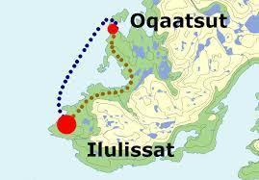

In class you can talk about:
- How do you get from Ilulissat to Oqaatsut?
- Why did the Dutch whalers call the place Rode Bay?
- What does it mean to live off tourism?
Listen and talk, pages 14-15
Now it is time for the students to listen to the podcast Life in the Settlements. They find the podcast by clicking on the picture on page 14.

Before the students listen to the podcast, you can give a short introduction to the contents of the podcast.

The contents of the podcast
Katrine tells:
- that for thousands of years people have met by the Disko Bay to hunt, trade and exchange culture and knowledge.
- that people went into the fjords to summer settlements to hunt and fish (reindeer, trout and halibut).
- about the winter settlement, Sermermiut of which you can see the ruins just south of the Icefjord Centre.
- that even though many people have moved to Ilulissat, several of them still have a hut in the settlement they come from.
Ole tells:
- that almost every Greenlander has his or her roots in a settlement and that this is the reason why the settlements have a special status.
- that the state up through the 50s and 60s closed down many settlements, but that this does not happen anymore…
- that he grew up in the settlement of Oqaatsut, but as a 9 year old moved to Ilulissat because of better schools and better prospects for the future. At that time, 50 years ago, approximately 200 people lived in Oqaatsut, but now only 30 people live there
- that it is hard work to live in the settlement. Everything is done by manpower. The wheelbarrow is the most important means of transportation. Here there are no cars.
- that in the settlement there is a power plant – a waterworks – a municipal office - a small wash house – a small health Centre – a small church that also functions as a school.
- that you are dependent on having a boat, sled dogs or a snow scooter to get around.
- that he runs a hotel in the settlement, the place where he has his roots.
- that he enjoys the special settlement atmosphere, the view of the Icefjord. This is where he relaxes.
It is recommended that the students listen in pairs or small groups.
Let the students spend a few minutes discussing what they have heard in the podcast.
On page 15 the students are to record small audio files where they tell about the podcast. The pictures on the page will help them remember what they have heard.
Sound recording see instruction 1 here.

The recording will now be represented by a small sound icon. This icon can be placed wherever you wish on the page. You can listen to the recording over and over again.

Review in class
We recommend that you have a joint discussion in class when the work with pages 14-15 is finished.
In class you could talk about:
- The picture(s) they have chosen for their audio story and the reason why they have chosen it/them.
- Concepts and keywords the students have heard about in the podcast.
Below you can find inspiration for the class discussion.
For some of the concepts there are pages with tasks in the Book Creator book.
If you wish, you can add more pages for other topics, concepts and keywords that you discuss.

Concepts and keywords
- Disko Bay – is today one of the most popular tourist destinations in Greenland. It is an unbelievably beautiful area with the enormous floating icebergs, the rich wildlife and especially the many whales. This is also where you can experience the hunter life of the small settlements.
Even though hunting and fishing still are the main livelihood in the Disko Bay, the service professions are growing with the expanding tourism.

The Disko Island is called Qeqertarsuaq in Greenlandic. This means the big island. Why do you think it is called “Disko”?

- Settlement – A settlement is a smaller habitation than a town. In Denmark it is called a village. In order to get to a Greenlandic settlement, you must either use a boat, a dog sledge or a helicopter.
In Greenland there are over 60 settlements. A number of these are not inhabited. In the inhabited settlements between 30 to 250 people live.
If you do not walk, how do you get around in a settlement?
How do you get around where you live?

- Settlements – The first Stone Age people settled by the Icefjord 4400 years ago. They lived off hunting and fishing. Hunting and fishing are still the foundation of life around the Icefjord. Today fishing and the fishing industry are the most important occupations in Ilulissat, the third largest town in Greenland.

What do you think a settlement looked like?
From what did people live off 4400 years ago?

- Roots – Nearly all Greenlanders have grown up in a settlement themselves or have older family members that have. This is where they come from, this is where they have their roots.

Where does your family come from?
Are you especially attached to the place where you were born?

Moving, pages 16-17
On page 16 the students read the text or have it read out loud.
Dear diary,
Today is Monday. Today we are moving to Ilulissat.
I am looking forward to seeing Ilulissat.
But I am also sorry to have to say goodbye to my friends.
I am a bit worried about whether I will get any friends in the new school.
My parents want to move because there are more possibilities in town.
Luckily, they promise that we will always visit the settlement.
I am very happy about that. I love being here.
Ole, 9 years old

In class you can talk about the text. To support the students that cannot write a text themselves yet, we recommend that the students formulate their answers orally. Write their answers on the board so that the students can write them on their pages.

On page 17 they read the text or have it read out loud.
Write about a day in your life where something changed.

Insertion of text, picture or drawing: see instruction 2, 3 and 4 here.

Ole’s settlement, pages 18-19
On page 18 there is a picture of Ole’s settlement, Oqaatsut. In the settlement there are a power plant, a waterworks, a municipal office, a small wash house, a health centre and a church that also holds the school.
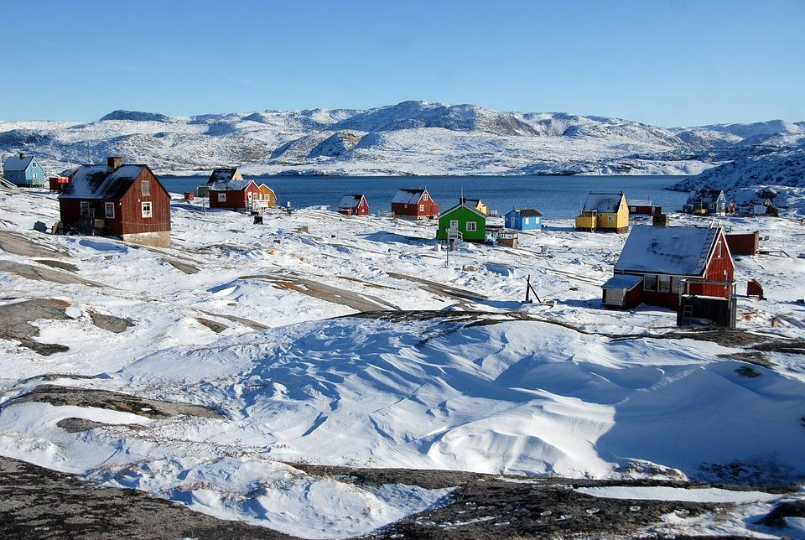

In class you can talk about:
- How many people live in the settlement?
- What it must be like to go to school in a church.

On page 19 the students are to find a picture of a house and a church and insert the pictures on the page. Make use of the function + images in the Book Creator book.
They are also to make an audio file where they tell what you can find in the building. They are to choose either a power plant, a waterworks, a municipal office, a small wash house, a health centre or a church that also holds the school.
Insertion of pictures: see instruction 2, 3 and 4 here.

The view, pages 20-21
On page 20 the students read the text or have it read out loud.
Ole owns a small hotel in Oqaatsut.
Ole tells that when you stand in front of the hotel and look down at Ilulissat, you can see more of the Icefjord than you can from Ilulissat.
This he thinks is a little funny.
On page 21 the students make a painting of the view from the hotel. When the painting is finished, they take a picture of it and insert the picture on the page.
They can find inspiration by looking for pictures in pixabay. In the search box they write Isfjorden.

Insertion of pictures: see instruction 2 here.

My reference book, pages 22-23
On these pages the students write sentences or small stories using the keywords and concepts that you have been through. They can write them, record them as an audio file or make a drawing and insert the picture.

Sound recording and insertion of pictures: see instruction 1 and 2 here.

Life in the settlement, pages 24-25
As a conclusion of their work with the podcast, the students now make a model of the houses and the church in Oqaatsut. They must also make models of the people who live in the settlement.
We recommend that the students work in pairs or small groups. Each group is to make at least one model. All the models are put together to form the settlement. When the joint model of the settlement is finished, you take a picture of it and insert the picture on the pages.

Insertion of pictures: see instruction 2 and 3 here.

Evaluation
The students show their products to the class.
Make sure that the framework for feedback is positive criticism. The students should be supported in assessing what is good – and what might be done better. Find more inspiration here.
Not specifically with a view to making new products, but foremost to let the students discover and work with this kind of constructive and positive criticism.
If you intend to work with some of the other podcasts from the Icefjord Centre, it might make sense to save the students’ Book Creator book, so the work they have done with it can be used again.

If you wish to let the students make use of the feedback they have received from the class, you could reserve time for them to continue their work with their products. So that they can use the feedback they have received from each other and change things in their product.

Colophon
The podcast Life in the Settlements has been created by the Icefjord Centre in Ilulissat.
The teaching material for the podcast Life in the Settlements has been developed by Lotte Brinkmann and Daniella Maria Manuel, Anholt Læringsværksted with feedback from Leg med IT.
The student’s book in Book Creator has been developed by Rikke Falkenberg Kofoed from Leg med IT.
The teaching material Life in the Settlements is published under a Creative Commons crediting licence CC:BY.
The texts, assignments and pictures can be shared, reproduced and adapted, with the proviso that “Life in the Settlements by The Icefjord Centre Ilulissat” is credited as the source.

